Application for the Member of ICTMHW and CICAMR
国际传统医学大會和加拿大整体医学研究院成员申请表
Please fill the Application Form in English/Chinese请用英文/中文填写
Name  姓名 |  | Highest Educational Degree  最高学历
Sex 性别 |  | Major and Specialty  专业及专长
Age Group 年龄组 | 20-34  35-49  50-69  70+ | Professional Title  职称 | TCM doctor/中医师  Acupuncturist/针灸师  Massage Therapist/按摩师  Other/其它
Work Phone 工作电话 |  | Work Unit/Clinic 工作单位/诊所
Mobile 手机 |  | E-mail  电子邮件
WeChat 微信 |  | Mailing Address 邮寄地址
Nationality 国籍 |  | Date of Application 申请日期
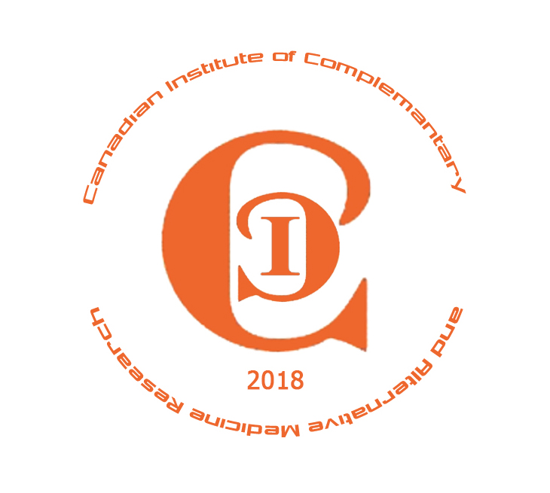
International Conference of Traditional Medicines on Health and Wellness ICTMHW 国际传统医学大會
Canadian Institute of Complementary and Alternative Medicine Research
CICAMR加拿大整体医学研究院
Website: http://www.ictmhw.com， http://www.cicamr.org

Person in Charge 经办人 |  | Date of Process 办理日期

